To Submit Applications for 2017 Spring Musical Theater NATS at College of Charleston:

1. Go to www.nats.org and log in:
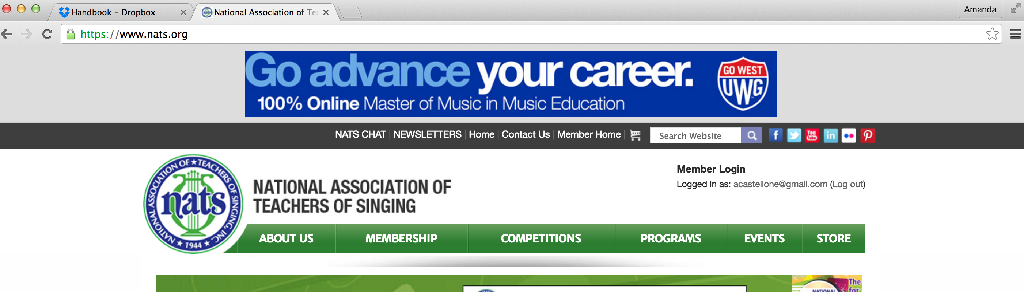

2. Click “Member Home” within the top bar:

3. Click “NATS Auditions Registration” button:
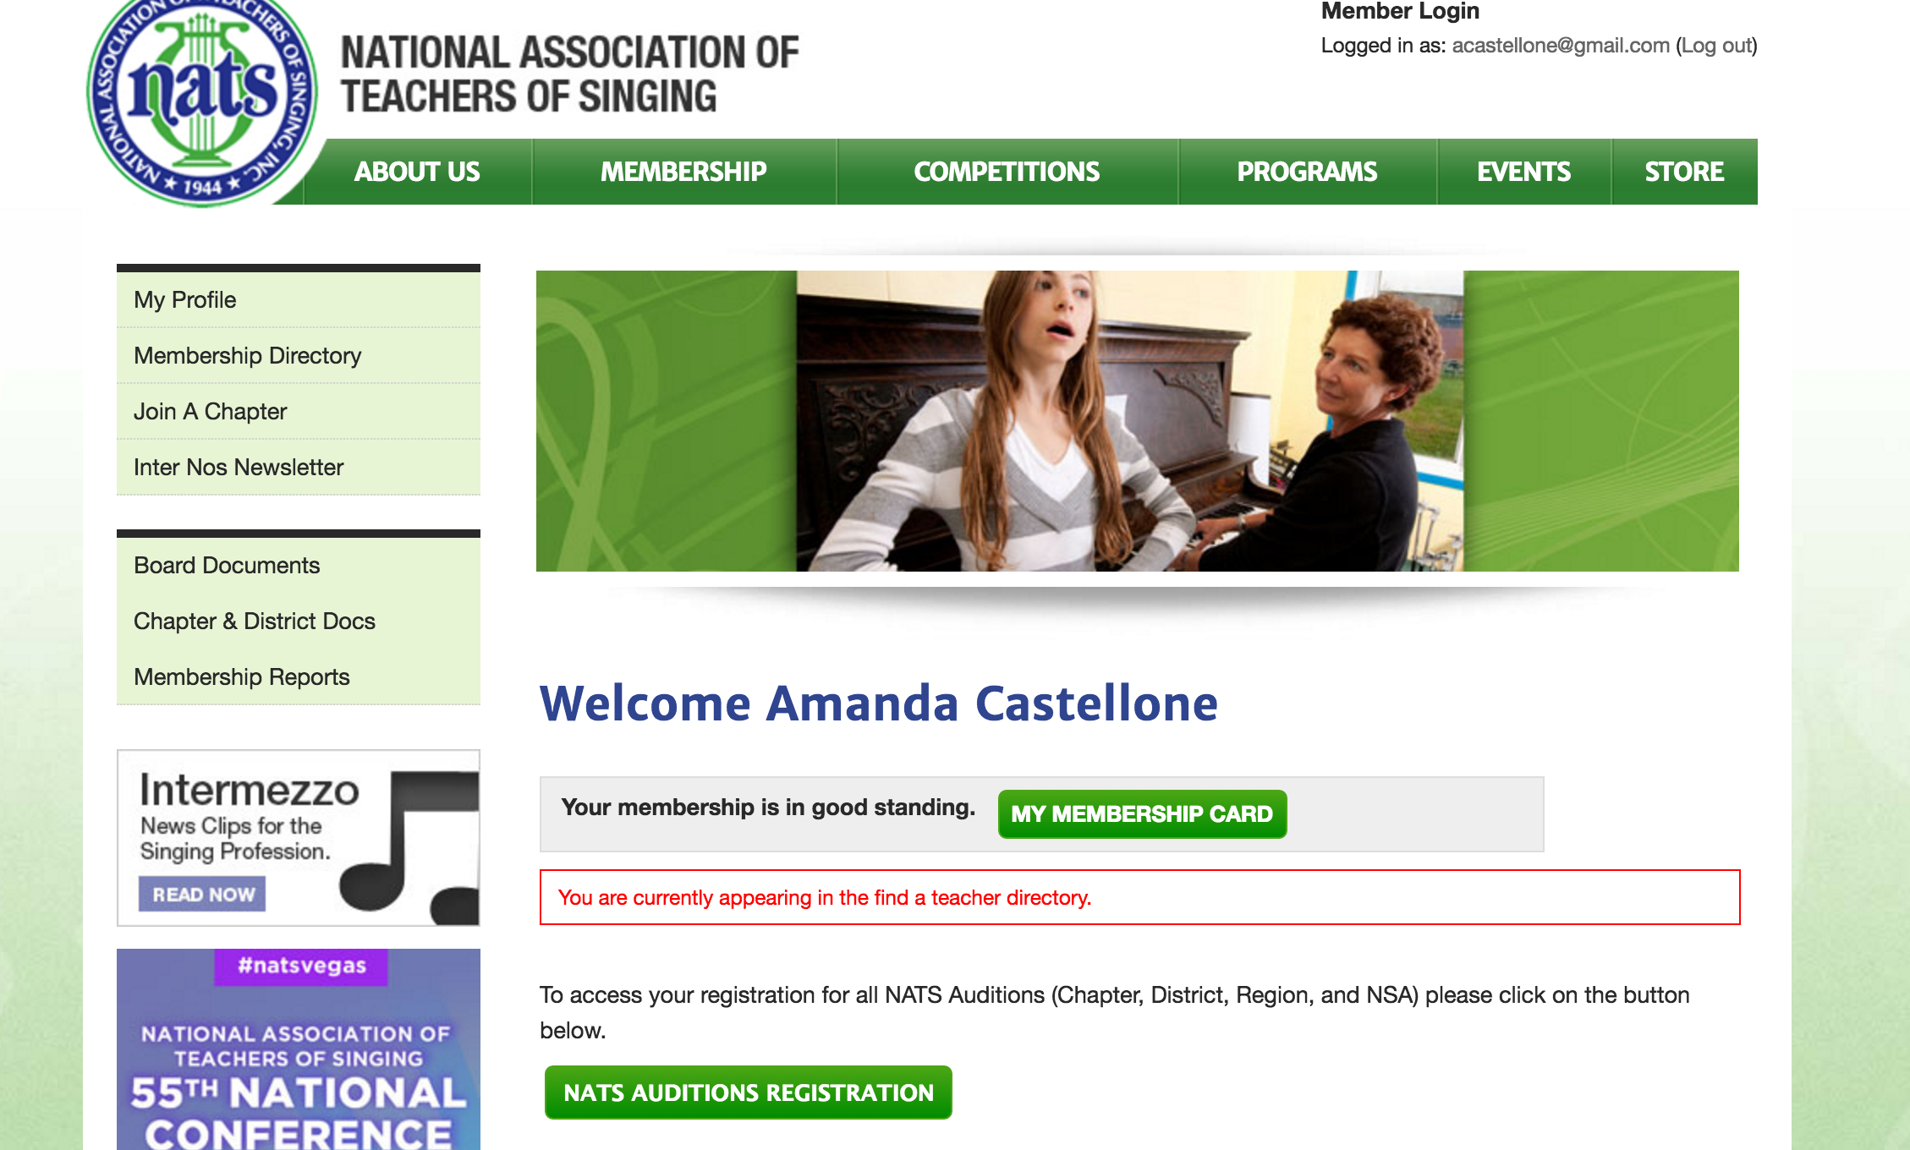

4. Click “South Carolina-Spring 2017 SC Classical NATS within “Competition Info”
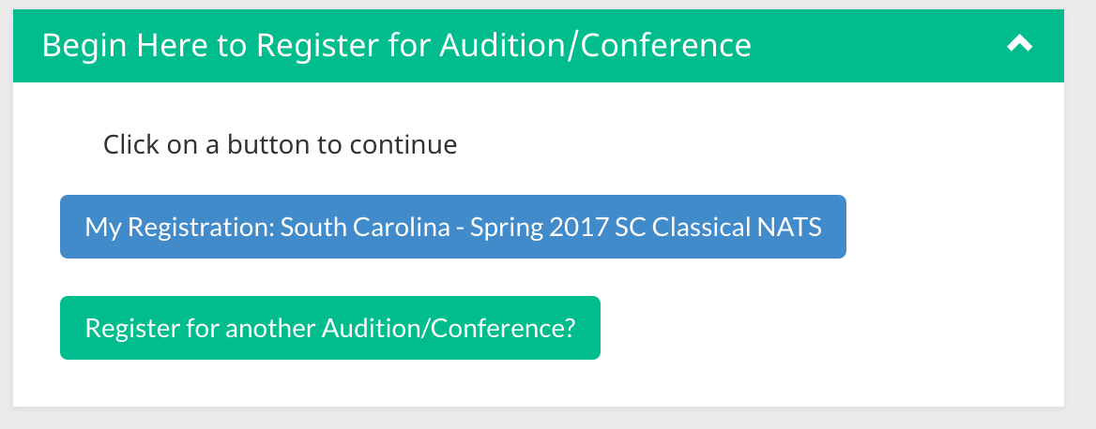

5. Complete student registration:
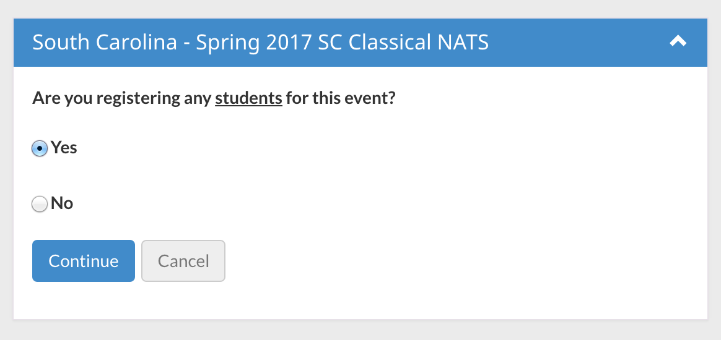

Thank you for your patience as the look of the registration website has gone through changes!
-Amanda Castellone

