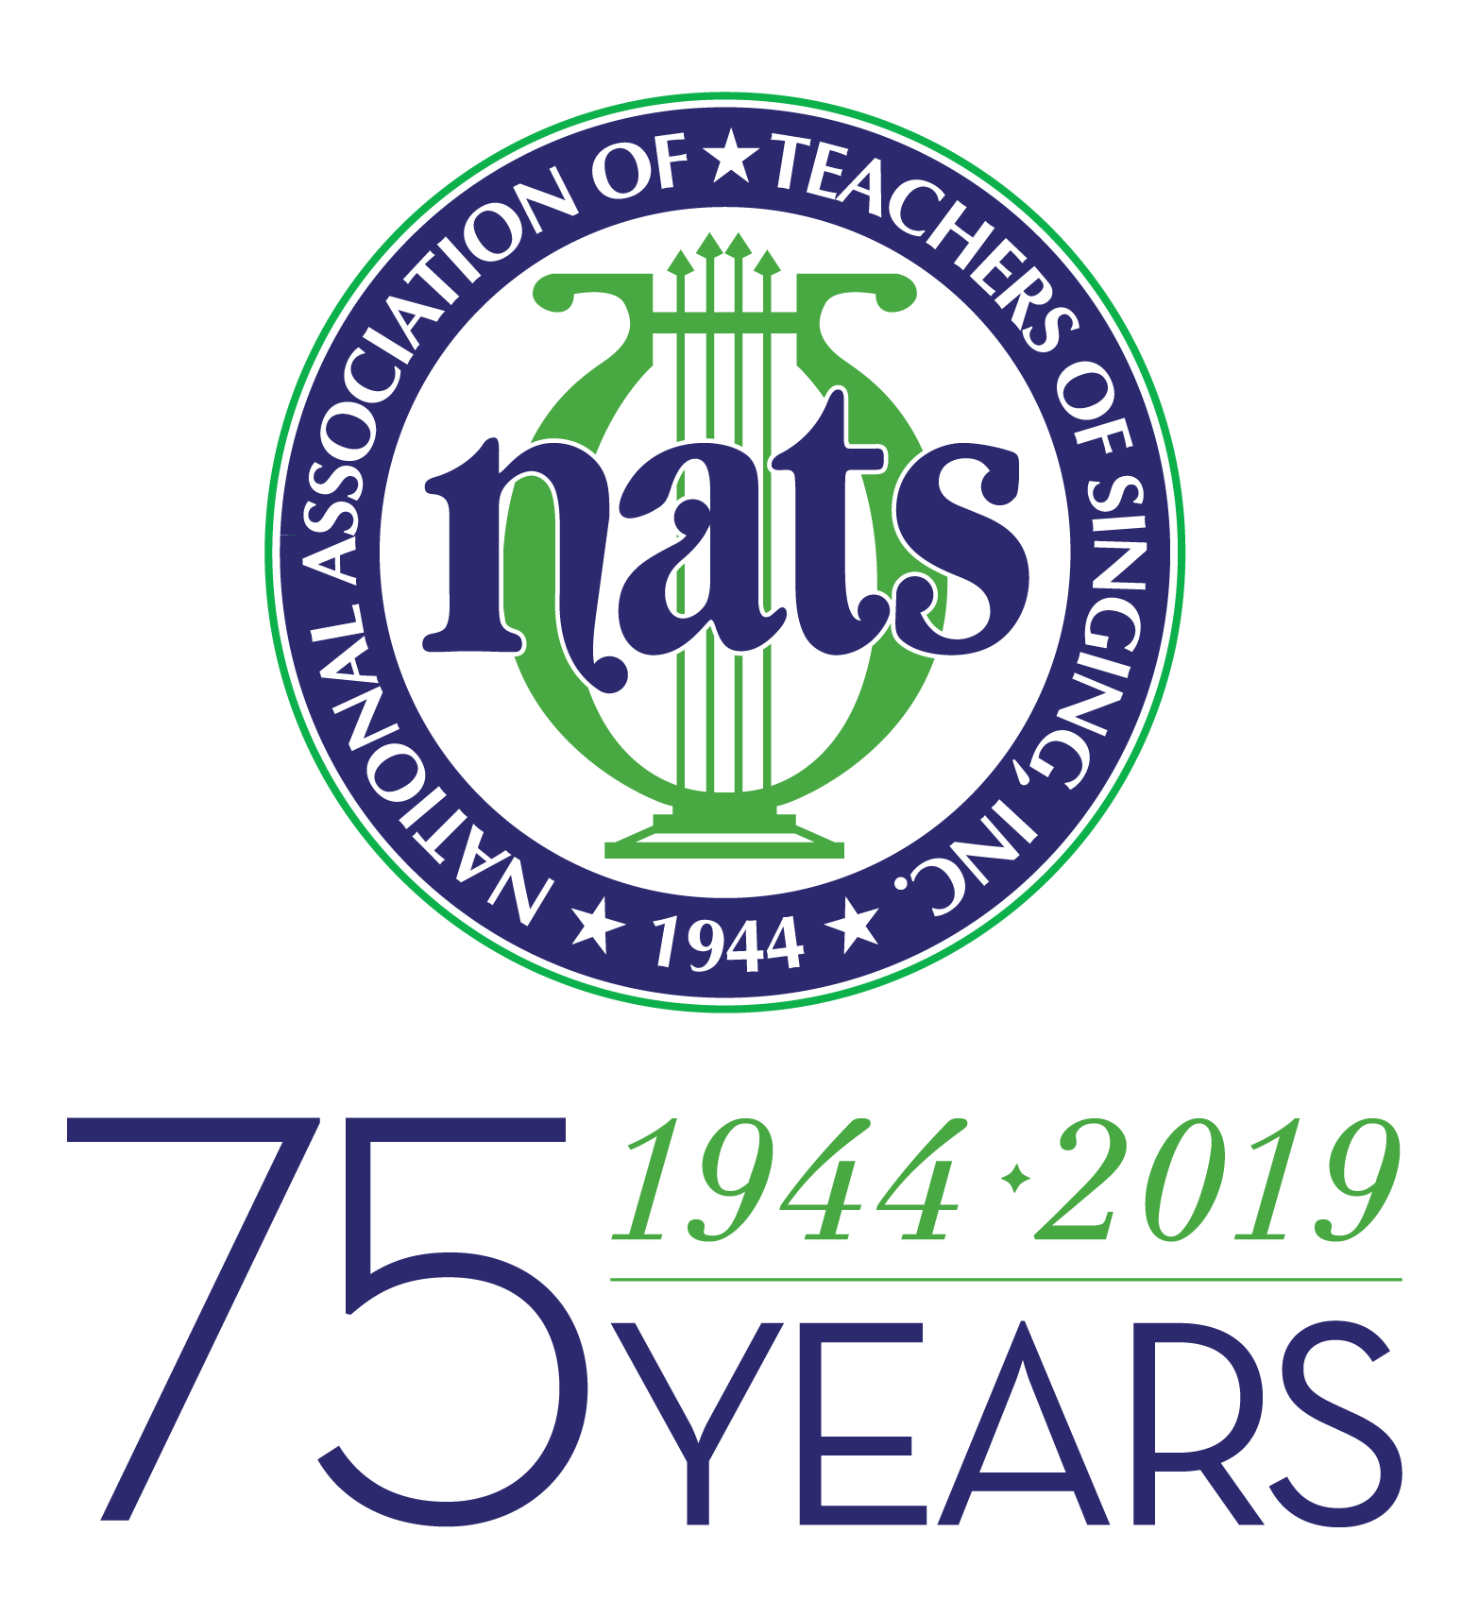

For more information:
Jill Terhaar Lewis, SCNATS Dist. Gov.: jlewis@csuniv.edu

For Immediate Release
8/25/18

SC District of National Association of Teachers of Singing Announces Outreach Workshops
Free events in three venues across the state in September.

South Carolina — August 25, 2018 — The South Carolina District of the National Association of Teachers of Singing (NATS) will be hosting three free Outreach Workshop events across the state during the month of September. These workshops will be headed by three outstanding SCNATS members and are open to the community.
Workshops will include a group session where the clinician will work with all attendees in group activities instructing in areas related to vocal health, singing techniques, and performances. A second session will include a master class where the clinician will work with individual singers preselected for the event. Choir directors and members from area high schools churches, and other groups are encouraged to attend. Information about SCNATS and membership will also be available.
The first workshop will be held at Clemson University on September 8. The clinician will be Dr. Seth Killen, tenor. In addition to maintaining an active performing career, Dr. Killen teaches at North Greenville University. Killen will be presenting a session entitled, "Owning the Song," in which singers will be shown strategies to learn music quickly, to make acting choices that are supported by the music, and to deliver a personal, moving performance. He will also be leading a Master Class featuring selected students of SCNATS members. The workshop will be held in the Brooks Center for the Performing Arts, room 117 (choir room) of Clemson University.
On September 22, Dr. Jennifer Luiken, mezzo-soprano, will be the guest clinician with an opening session entitled. “Be Yourself—Making Your Voice Your Own.” This session is for singers of all ages and levels and will focus on connecting the speaking voice to the singing voice, helping singers to find their individual and unique voices. In the second session, Dr. Luiken will be working with selected singers in classical and music theater techniques. Dr. Luiken enjoys an active performing career and is a Professor of Music at Charleston Southern University. The venue of this event will be announced. Check in at scnats.org for more details closer to the date.
The final workshop on September 29 will feature soprano Deedy Welborn Francis as guest clinician at Francis Marion University. She is an Associate Professor of Music at Anderson University. In her first session, Ms. Francis will present “Body Mapping: Laying a Foundation for Vocal Techniques.” Students of all ages will work in groups to learn about body mapping and how it can improve vocal technique. The second session will feature selected singers in a Master Class with Ms. Francis. For complete schedules and venue information, check the SCNATS webpage http://www.scnats.org.
Founded in 1944, National Association of Teachers of Singing, Inc. (NATS) is the largest professional association of teachers of singing in the world with nearly 7,000 members in the United States, Canada, and nearly 30 other countries. NATS has a mission to encourage the highest standards of the vocal art and of ethical principles in the teaching of singing; and to promote vocal education and research at all levels, both for the enrichment of the general public and for the professional advancement of the talented. The South Carolina District of NATS consists of 113 members including teachers of singing of students of all age levels including preteen through advanced adults, choral directors, and collaborative pianists. SCNATS hosts conferences and events throughout the academic year including workshops and the NATS National Student Auditions.
For more information on NATS, visit nats.org or contact the SCNATS District Governor Dr. Jill Terhaar Lewis at jlewis@csuniv.edu. These events are partially funded by a NATS Discretionary Fund Grant.

South Carolina NATS

Outreach Workshops

September 8, 2018 at Clemson Univeristy, Clemson

Host: Lisa Odom of Clemson University

Clinician: Dr. Seth Killen

Schedule:

9:00 am Registration

9:30 am Session One: "Owning the Song"

10:45 am BREAK

11:00 am Session Two: Master Class

12:30 pm End

September 22, 2018 (TBA), Bluffton

Hosts: Laura Floyd (Independent Teacher) and Jason Snyder of May River High School

Clinician: Dr. Jennifer Luiken

Schedule:

9:00 am Registration

9:30 am Session One: "Be Yourself -- Making Your

Voice Your Own"

10:45 am BREAK

11:00 am Session Two: Master Class

12:30 pm End September 29, 2018

September 29, 2018 at Francis Marion University, Florence

Hosts: Sharyn Mapes (Independent Teacher) and Fran Coleman of Francis Marion University

Clinician: Ms. Deedy Francis

Schedule:

9:00 am Registration

9:30 am Session One: “Body Mapping: Laying a

Foundation for Vocal Technique"

10:45 am BREAK

11:00 am Session Two: Master Class

12:30 pm End

