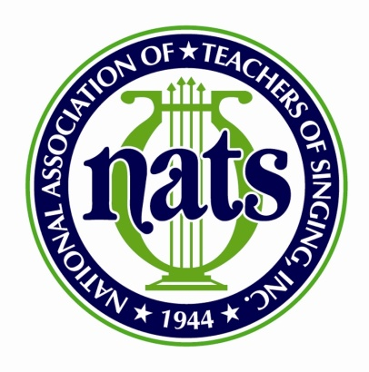
Call for Poster Presentations
NATS Mid-Atlantic Regional Conference and Student Auditions
March 16 and 17, 2018
Liberty University-Lynchburg, VA
Submission Dates: We will receive submissions from
January 1, 2018 through February 20, 2018
NATS Mid-Atlantic active members in good standing and students are invited to submit proposals for special sessions to be presented at the 2018 NATS Mid-Atlantic Region Conference and Student Auditions. Proposed poster presentations should appeal to both STUDENTS and TEACHERS. Proposals will be selected by the NATS Mid-Atlantic Proposal Review Committee. All proposals MUST be submitted via email to Brian Nedvin bnedvin@odu.edu and Kristen Wunderlich wonderlichk@winthrop.edu
Note: Presenters must be registered for the 2018 NATS Mid-Atlantic Regional Conference and Student Auditions. They will be required to provide their own materials (handouts, etc) and will be responsible for any travel and lodging, as needed.
The following items will be required as part of the application process via email:
- Name and e-mail of one active NATS member we may contact who may verify your expertise in the area you are proposing.
- A PDF document of a narrative describing the poster in detail (2-page maximum)
- Poster Presentation Title
- Presenter Name
- Employer/University
- Email
- Cell Phone
- Mailing Address
- Other Phone
- Website
- Presenter Bio (maximum of 150 words)
- Headshot

